Commercial satellites

-By
SaiHareesha Tirumala.
.

ExecutiveSummary:-
The project aims towards creation of a database for commercial satellites,tounderstandtheirbusinessmodel,OperationsModel, Revenue Model. We try to understand and perform operations on few of the questions that we to understand about their business, we aim towards concentrating theoperations towards the top satellite companies of the United states
We also want to understand the operations pattern towards wheretheirsalesareoperatedfromandto,wetrytoconcentrate on the aspects of understanding where the sales has been more and which has been the most optimum, a performance based analysis in the form of operations help us find out these aspects
Lastlywetrytounderstandtherevenuemodelasinwhichclient hasbeenprofitable,whichmodelhasbeenprofitableandwhich region has been profitable in terms of total revenue earned by the company.

Project background: -
*Thesedayswecanseetherearemanyusesfromcommercial satellites. Satellite services composes the largest share of the commercial space market, and includes communications, broadband internet, direct-to-home television, radio, and imaging/mapping services.
*“Over the past five years, record numbers of satellites have beendeployed,coststomanufactureandlaunchhave decreased while utility has increased – all leading to increased affordability, productivity and new markets. Despite all these new benefits, we must not forget that onlythe satellite industry can deliver truly ubiquitous, high quality, reliable and often critical emergency space-based services that consumer, governmentandenterprisecustomersdemandbothathomeand around the world.”
*Many companies and countries are getting profited with these commercialsatellitessoinourprojectwearegoinglookatthese satellites, uses, companies, profits in our project.

ERDiagram:-
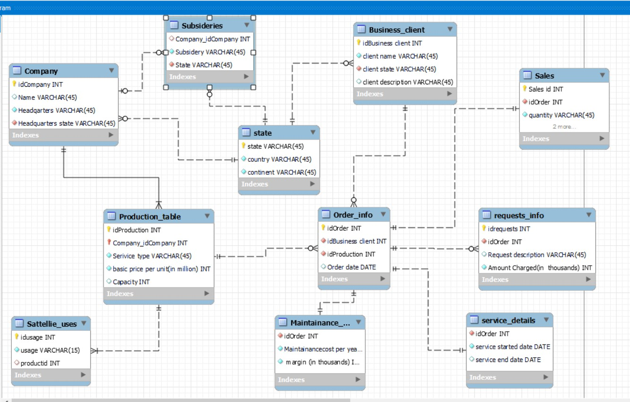

Tables:-
- states
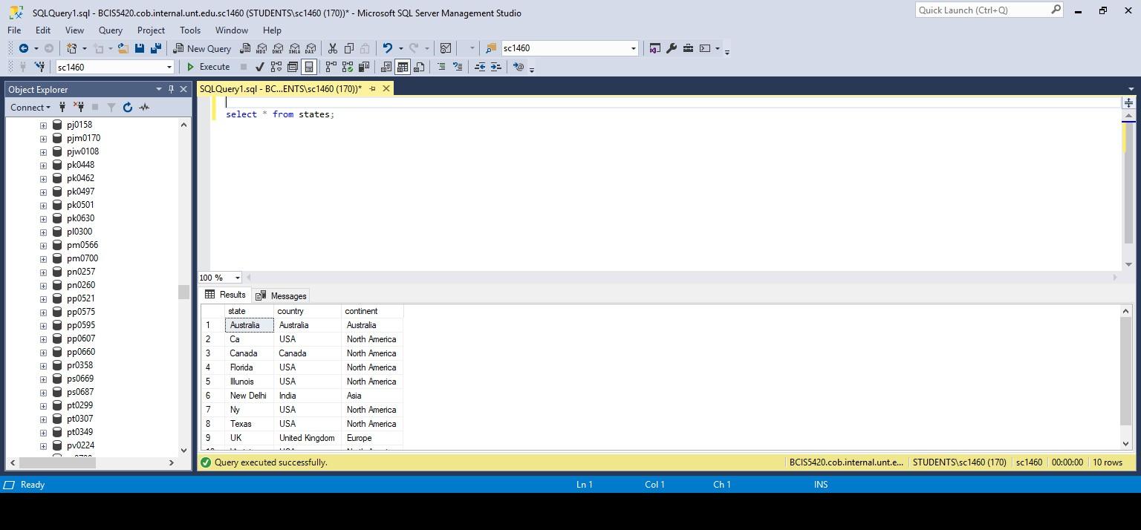
- company
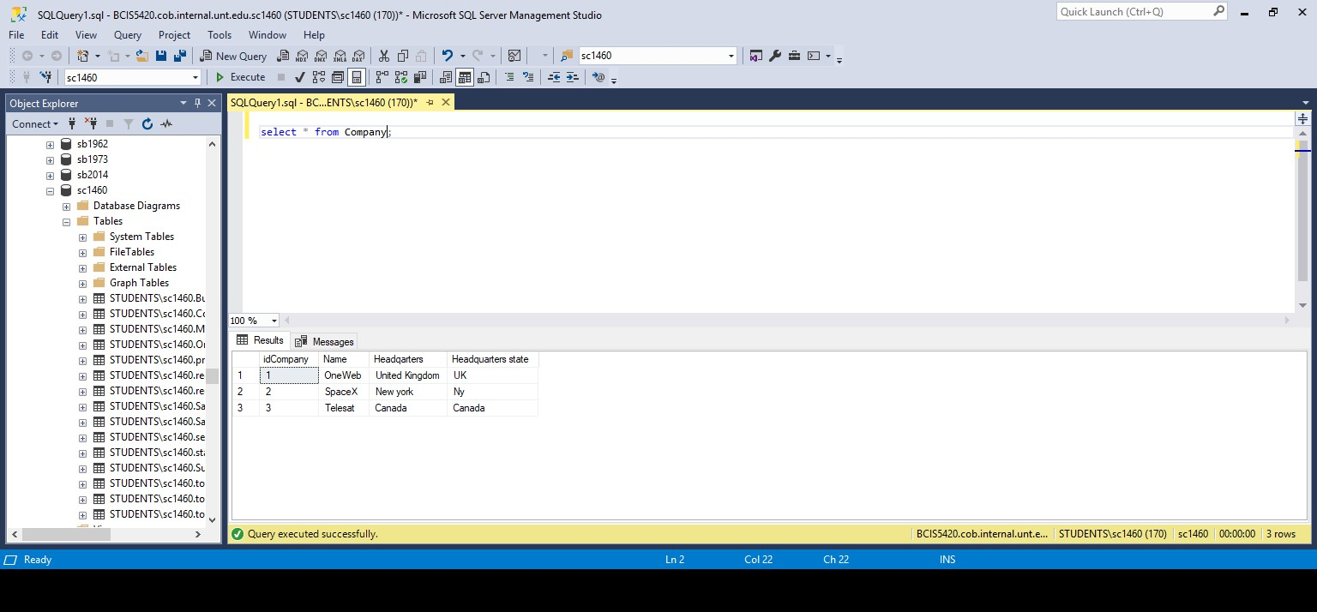

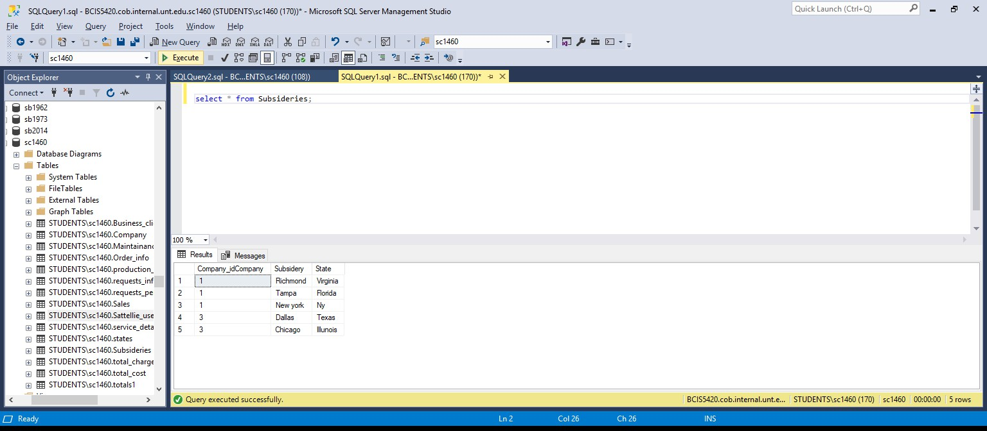
- subsidiaries
- production_table
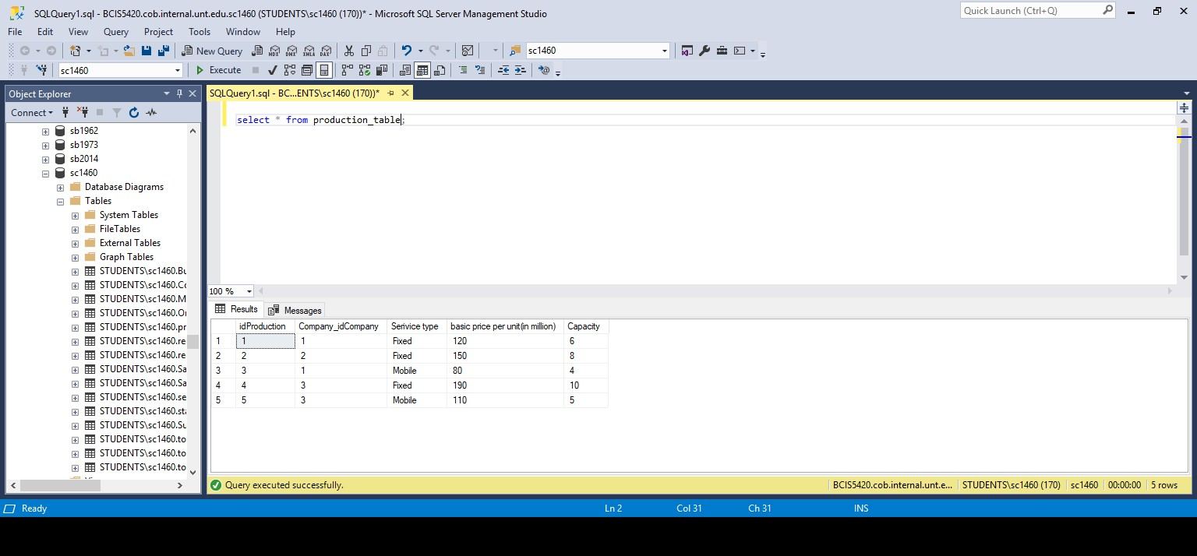

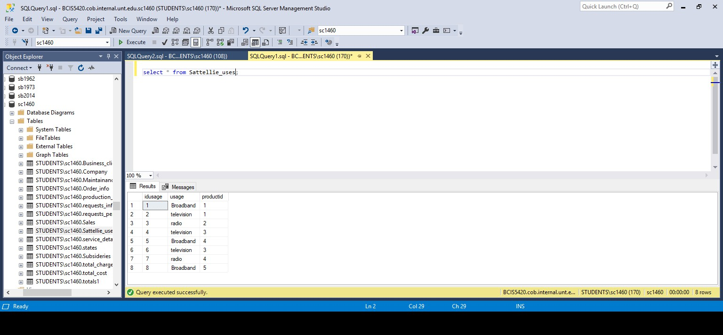
- sattellite_uses
- Business_client
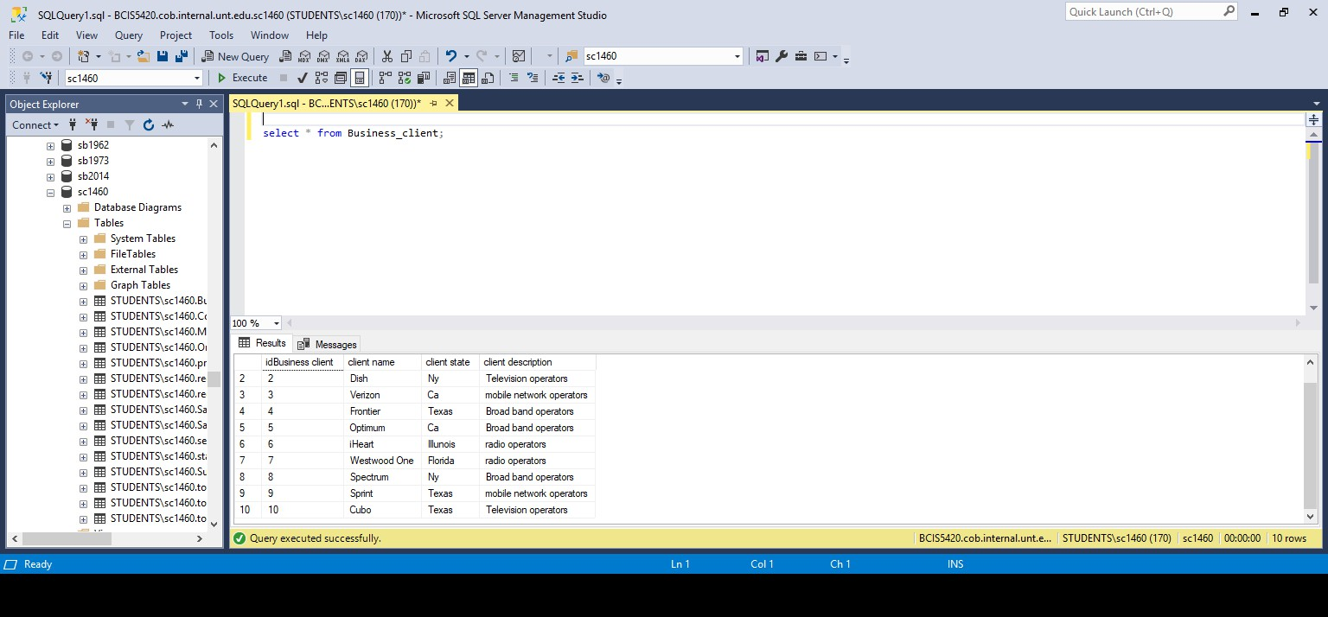

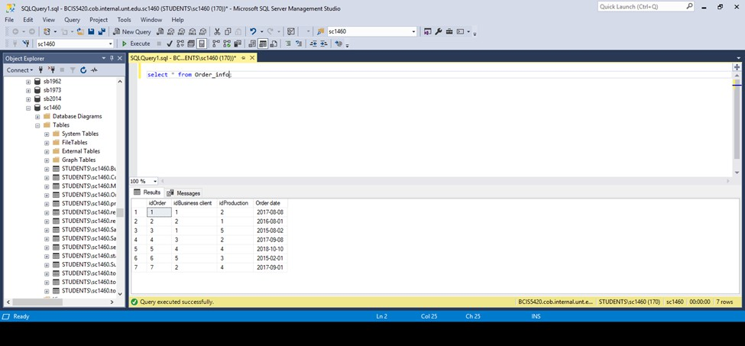
- Order_info
- Service_details
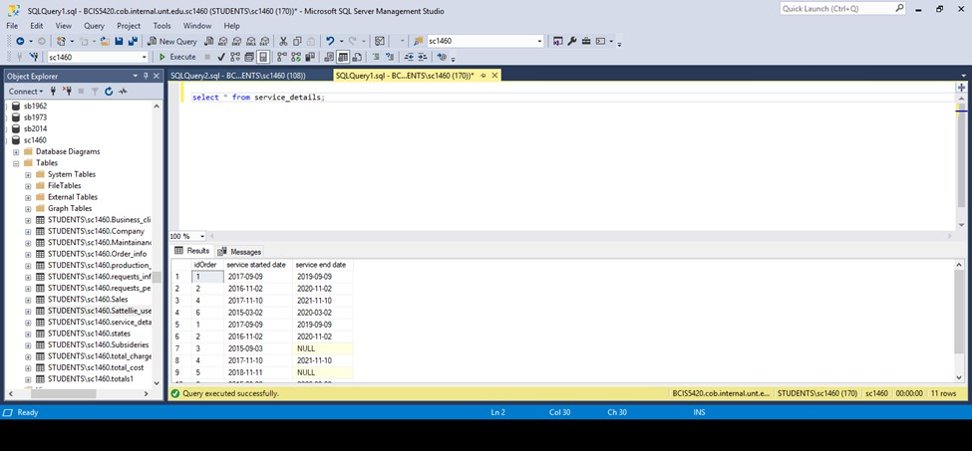

- Maintanence_info
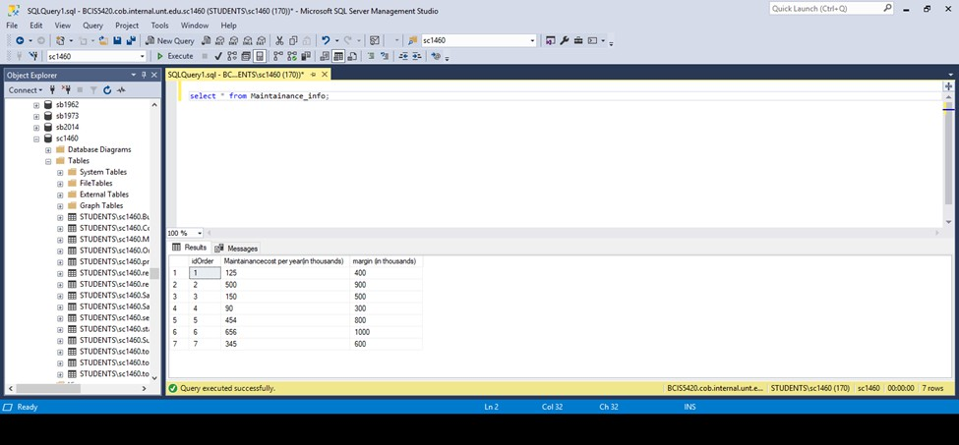
- Requests_info
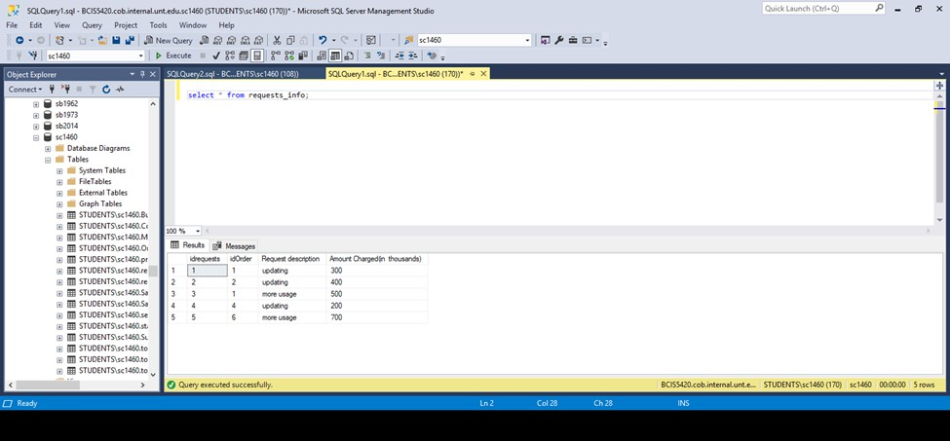

Queries:-
- Q.displaythecontinentand countryofallthe companies that have subsidiaries ?

Qureey-Select*fromstates,Subsiderieswhere states.state=Subsideries.State
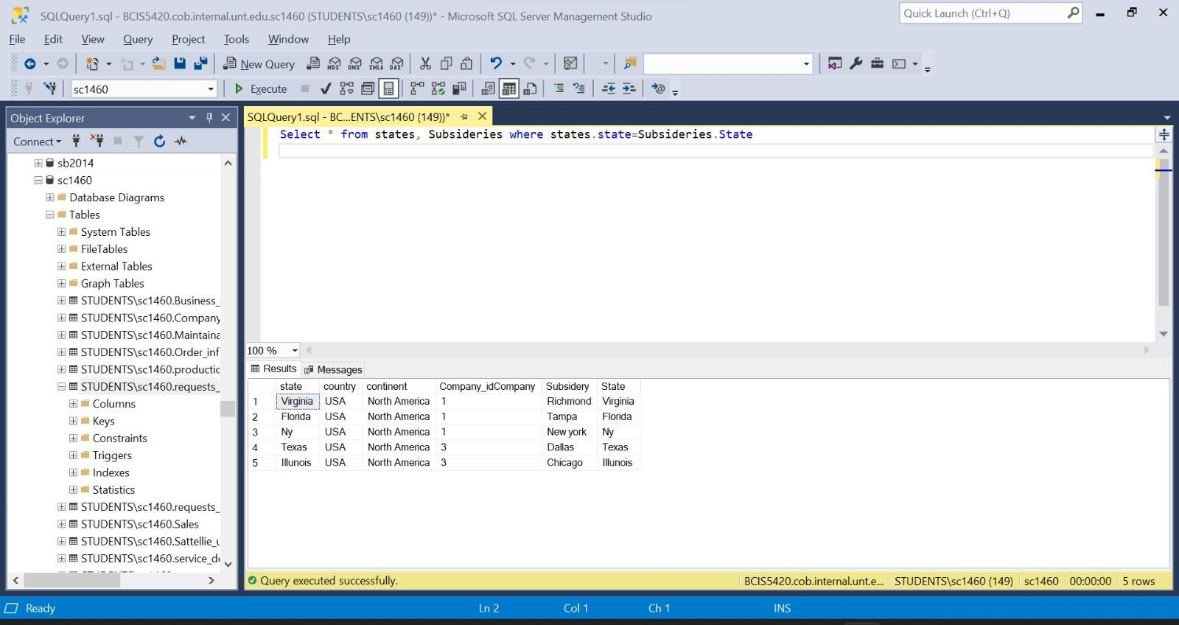
Comments:- we are trying to display the country band continents of the companies that have subsidiaries in termstoseethecountriesthathaveallowedcompaniesto have subsidiaries

- Lookingupclientswhohaveordered:-
Querie:select[clientname],[orderdate],idorderfrom Business_client,Order_info where Business_client.[idBusiness client]=Order_info.[idBusiness client]; -
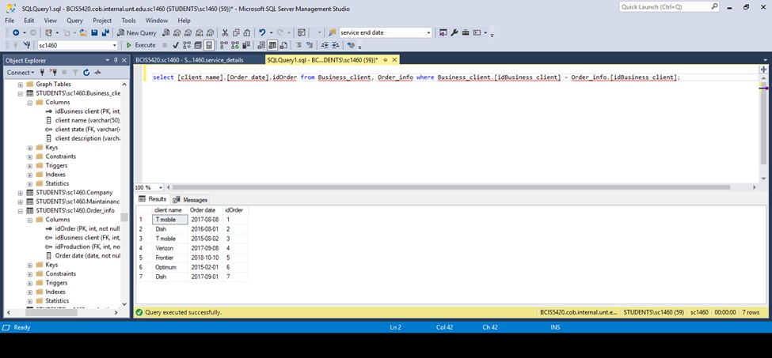
Comment:-wearetryingtounderstandandcallouttheclients that have made an order for satellites in past 3 years

- Lookingupforclientswhomaderequests
Querie: -select [client name],[Order date],Order_info.idorder,[Requestdescription]from Business_client,Order_info,requests_info where Business_client.[idBusiness client]=Order_info.[idBusiness client]and requests_info.idOrder=Order_info.idOrder;
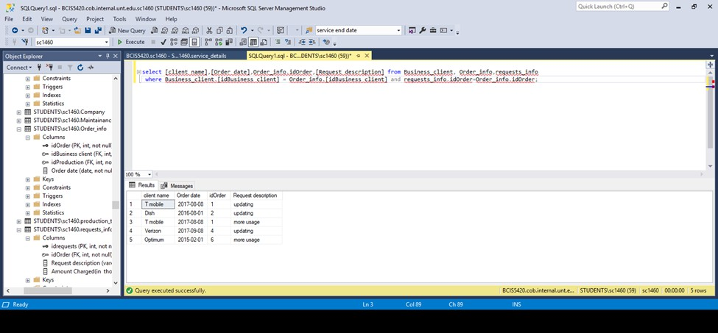
Comment:- we are trying to call out all those clients that havemadearequestandalsoreadwhattheirrequestwas

- Lookingupforid’sofproductionwhosemarginis greater than or equal to 100 million
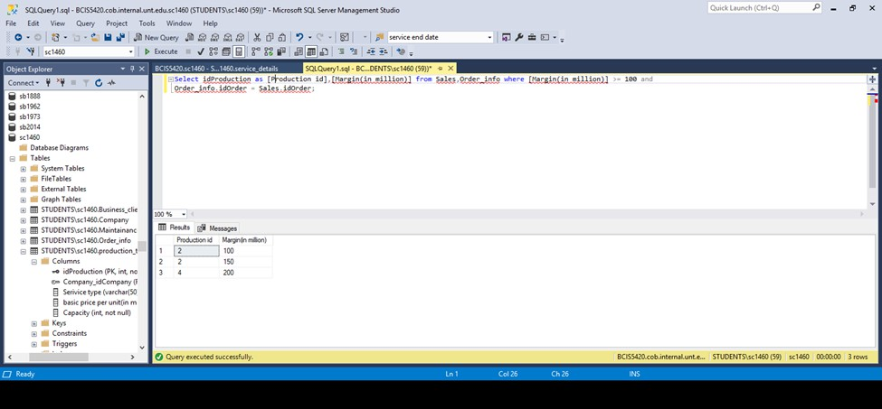
Querie:-selectidProductionas[Productionid],[Margin(in million)]from Sales,Order_info where [Margin(in million)]>=100 and Order_info.idOrder=Sales.idOrder;
Comment:- wearetryingtocallouttheproductionIDof those where the Margin in million has been greater than or equal to 100

- Lookingupcompany’sheadquarterscontinent
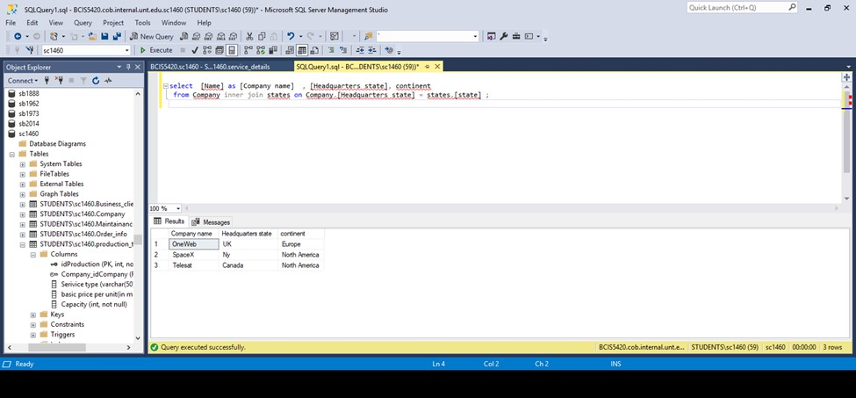
Querie:-select[name]as[Companyname],[Headquarters state],continent from Company inner join states on Company.[Headquarters state]=states.[state];
Comment:-Wearetryingtofindthecontinentinwhich each company’s headquarter lies using the tables company and states

- Lookingupforcompanyid’swhoprovidemultiple services
Querie: -select Company_idCompany as [company id],count(Company_idCompany) as [services] from Production_table Inner join Company ON Production_table.Company_idCompany=Company.idCo mpany group by Company_idCompany having count(Company_idCompany)>1
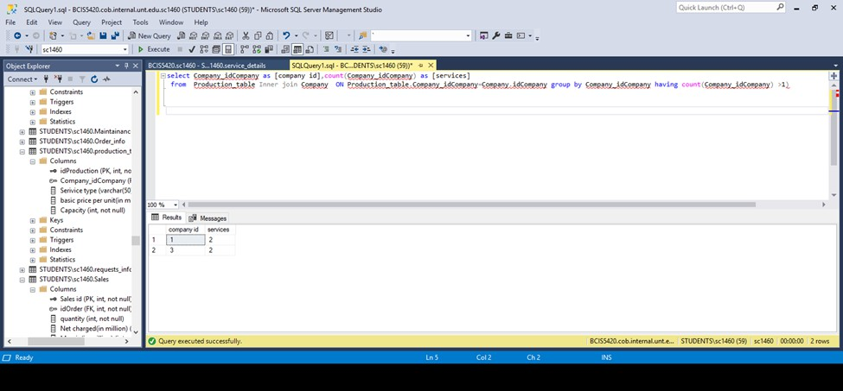
Comment:-Wearetryingtofindthosecompaniesthat are rendering more than 1 service overall

- Displayingtotalcostforeachyearincluding maintenance cost.
Querie: -select[idBusiness client],iif(year([service end date]) is null,2022- year([service started date]), year([service end date]),year([service end date])- year([service started date]))as[number of years],[Maintainancecost per year(in thousands)]*iif(year([service end data]) is null,2022-year([service started date]),year([serviceenddate])-year([servicestarteddate]))as[totalmaintanance cost],[net charged(in million)]*1000+[Maintainancecost per year(inthousands)]*iif(year([serviceenddate])isnull,2022-year([servicestarted date]),year([service end date])-year([service started date]))as[total cost in thousand]into total_costfrom Order_info,Maintainance_info,service_details,Saleswhere Order_info.idOrder=Maintainance_info.idOrder and Order_info.idOrder=service_details.idOrder and Order_info.idOrder=Sales.idOrder;
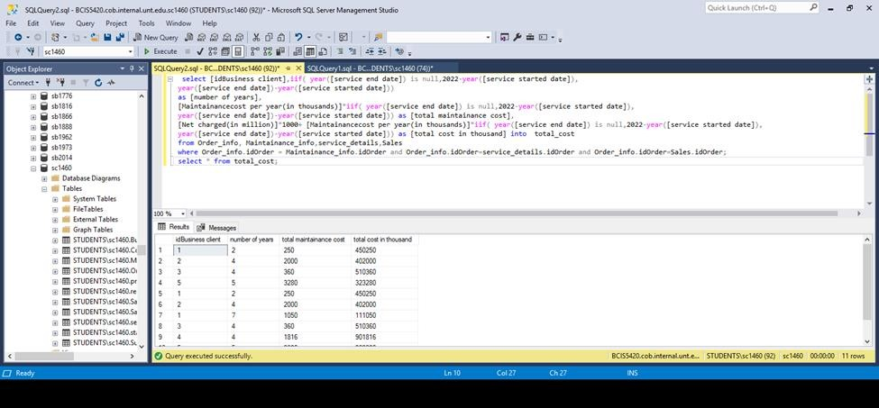
select*fromtotal_cost
Comment:-Wearelookingforwardtofindthetotalcost clubbed along with maintenance cost which help

usunderstandtheobjectiveofthetotalcostincurredeach year

- Groupingaboveresultsbyclientidandstoringin another table totals1
Querie: -select [idBusiness client],sum([total cost in thousand])as[totalcost]intototals1fromtotal_costgroup by [idBusiness client];
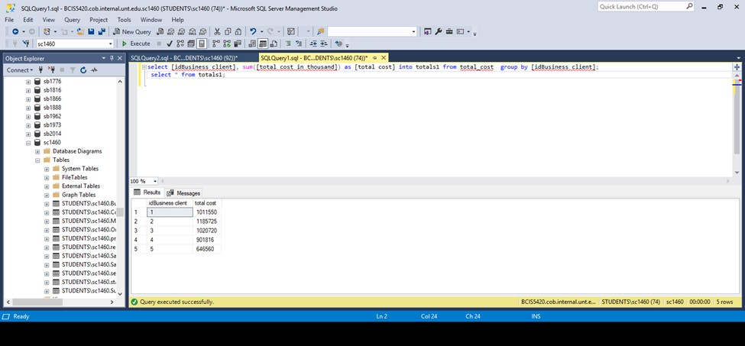
select*fromtotals1;
Comment:-wearetryingfindthetotalcostthathasbeen incurred by a business client while considering the Business id as the priority.

- Groupingtherequestchargesperorderandstoringin table create table requests_per_order
Querie: -select idOrder,sum([Amount Charged(in thousand)]) as [sum of charges for each other]into requests_per_orderfromrequests_infogoupbyidorder;
select*fromrequests_per_order;
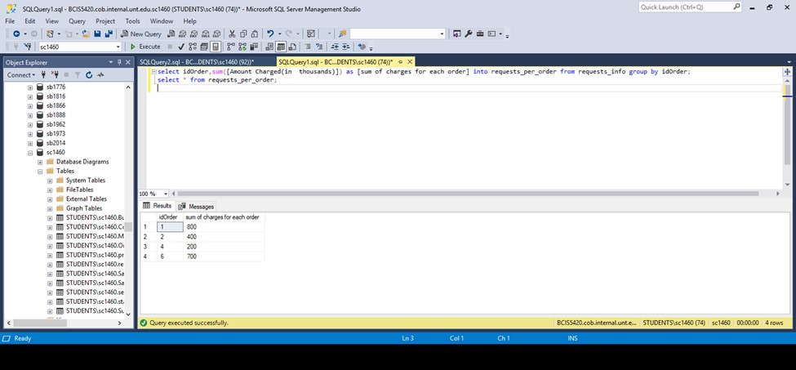
Comment:--wearetryingtofindthetotalchargethathas been levied by each company on an order by SUM (ing) the charges in the tables

- Displayingtotalcostincludingrequestchargesfor each clientid
Querie:-select[idBusinessclient],
iif([idBusinessclient]in(selectidOrderfromrequest_per_order),[totalcost]+
[sumofcharges forrachorder],[totalcost]) as[totalcostinthousand including request charges]into total_charges_including_requestcharge from totals1
leftjoinrequests_per_order
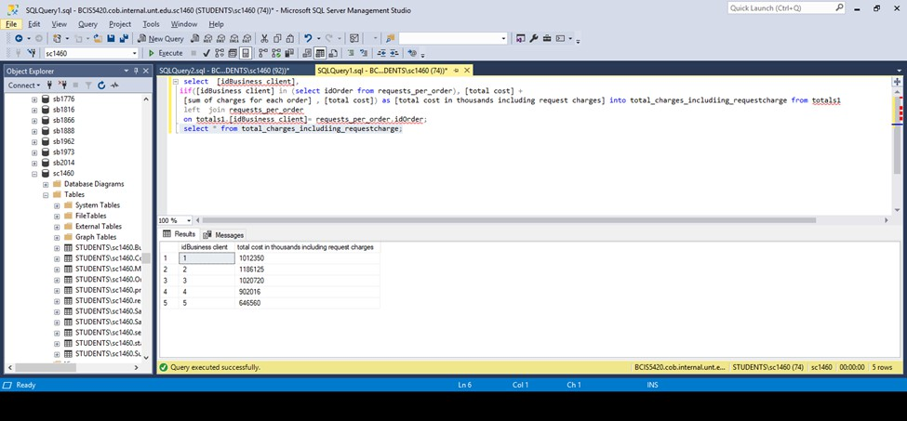
ontotals1.[idBusinessclient]=requests_per_order.idOrder; select* from total_charges_including_requestcharge;

Comment:-We are trying to understand the total cost alongwiththechargethathasbeenleviedbyeachrequest for the Clients ordered by the Business ID’s

- Displayingclientnamealongwiththetotalcharges spend by them
Querie:select[clientname],[totalcostinthousand including request charges] from Business_client
innerjointotal_charges_including_requestcharge
on Business_client.[idBusiness client]=total_charges_including_requestcharge.[idBusines s client]; -
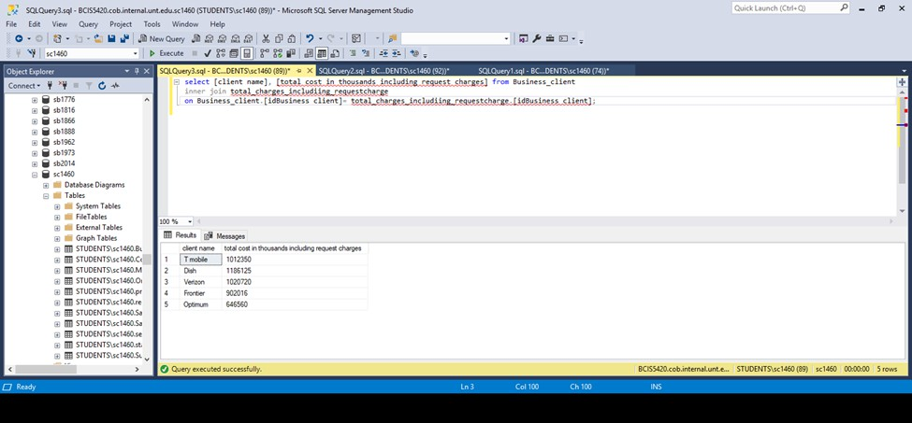
Comment: -We are trying to understand the total cost alongwiththechargethathasbeenleviedbyeachrequest for the Clients ordered by the Business ID’s

- Displayingmarginformaintenanceandmarginfor ordering for each order.
Querie:-selectMaintainance_info.idOrder,[Margin(in thousands)] as [maintainance per year in Thousands],
[Margin(inmillion)]fromMaintainance_info,Saleswhere Maintainance_info.idOrder=Sales.idOrder;
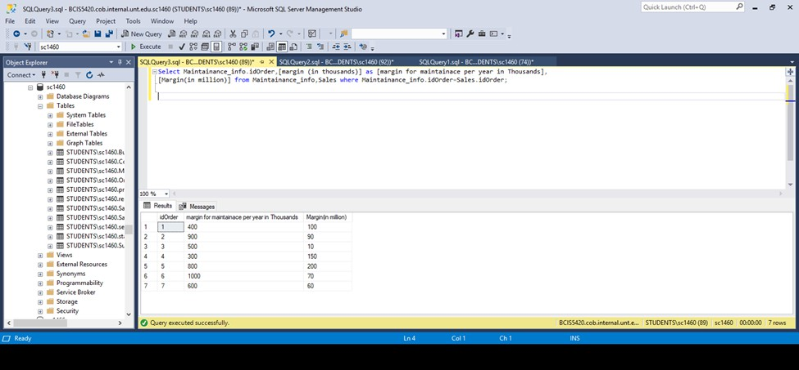
Comment:-wearetryingtofindthemarginofmaintance along with that understand the margin of ordering

- Displayingthemonth,theserviceended
Querie: -select [client name],service_details.idOrder,month([serviceenddate]) as [service end month] from service_details,Business_client,Order_info where service_details.idOrder=Order_info.idOrder and Business_client.[idBusiness client]=Order_info.[idBusiness client];
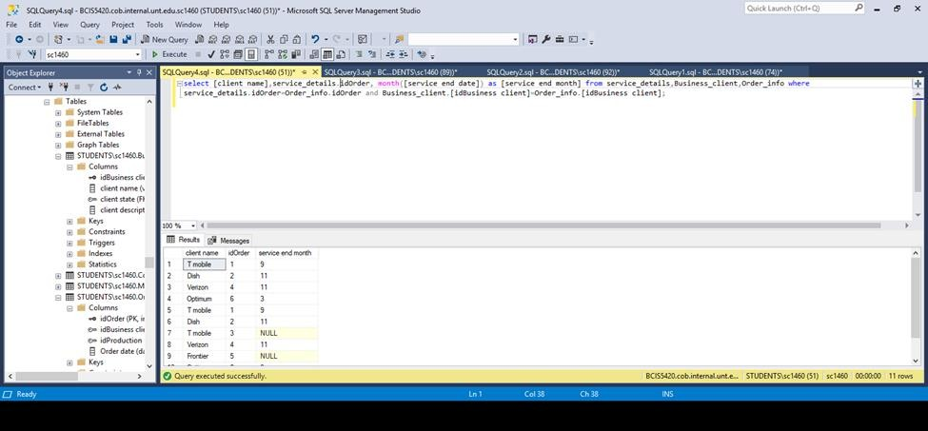
Comment: - We are trying to understand the year and monththeservicewasterminatedtocheckandunderstand the months/ years each client had rendered service to

- Displayingdetailsofcompanieswhohavesubsidiaries
Querie : -select * from Company,Subsiders where Company.idCompany=Subsiders.Company_idCompany;
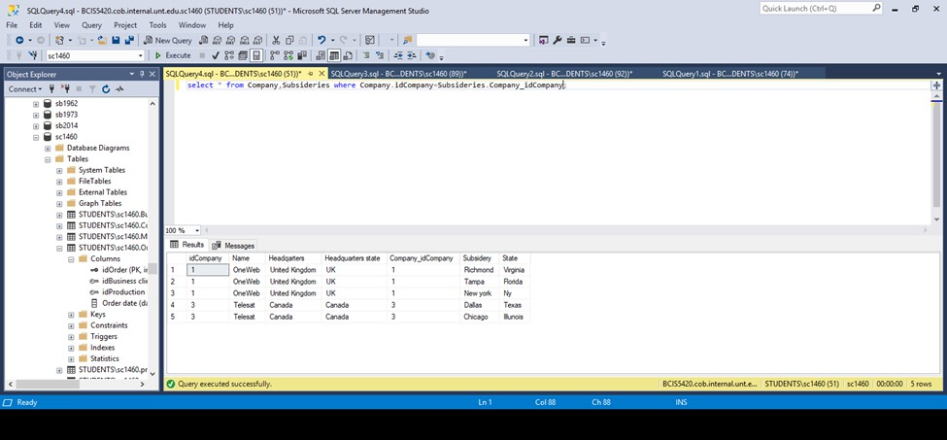
Comment:--wearetryingtounderstandthecompanies that have subsidiaries using the tables company and subsidiaries.

- Displayingcompanieswhoprovidefixedservices
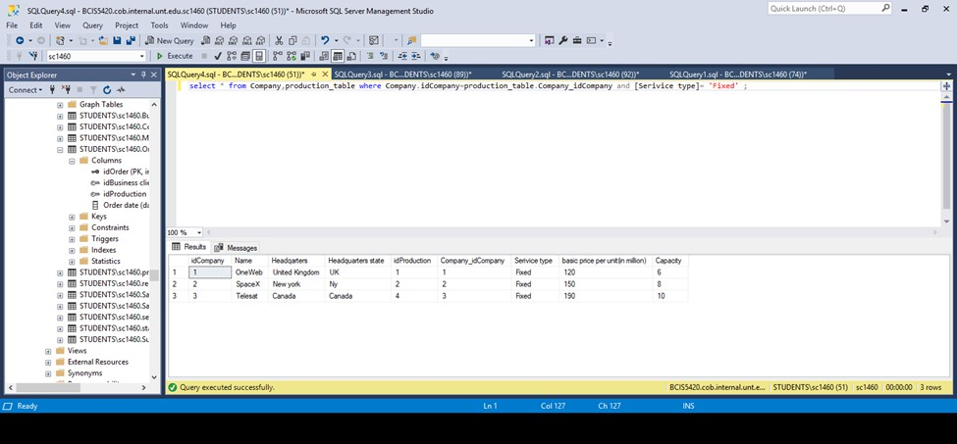
Querie:-select*fromCompany,Production_tablewhere Company.idCompany=Production_table.Company_idCo mpany and [Service type]='fixed';
Comment: -- we are trying to find the companies who havebeenattendedintermsofservicebyusingthekey word fixed inthe operation

- Displayingproductdetailswhosecapacity>5andused or televisions
Querie:-select*fromproduction_table,Sattellie_uses where production=idProduction and Capacity>5 and usage='television';
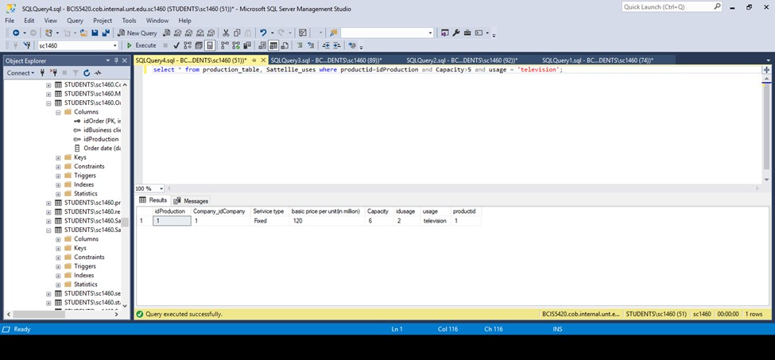
Comment:-We are trying to pin point a usage called televisionwherethecapacityhasbeengreaterthan5and has the same productionid and Id Production

- Displayingclientswhoseordered in2017and2018
Querie: -select * from Business_client,Order_info where Order_info.[idBusinessclient]=Business_client.[idBusiness client] and year(Order_info.[Order date]) in (2017,2018);
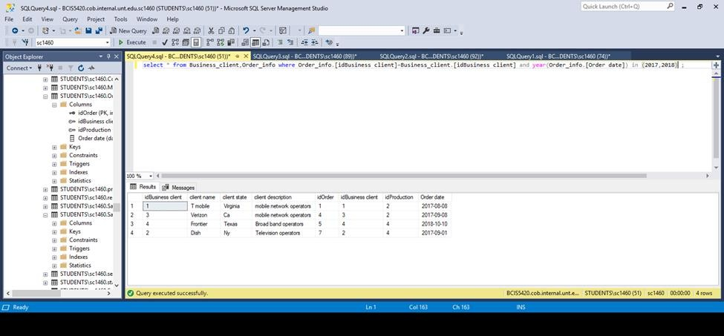
Comment:-wearetryingtodisplayclientname,client description and business client and production

- Displayingclientswhoareinheadquartersstateofany company
Querie: -select [client name],[client state],country,continent from Business_client,states where states.state=Business_client.[clientstate]and[clientstate]in (select [Headquarters state] from company);
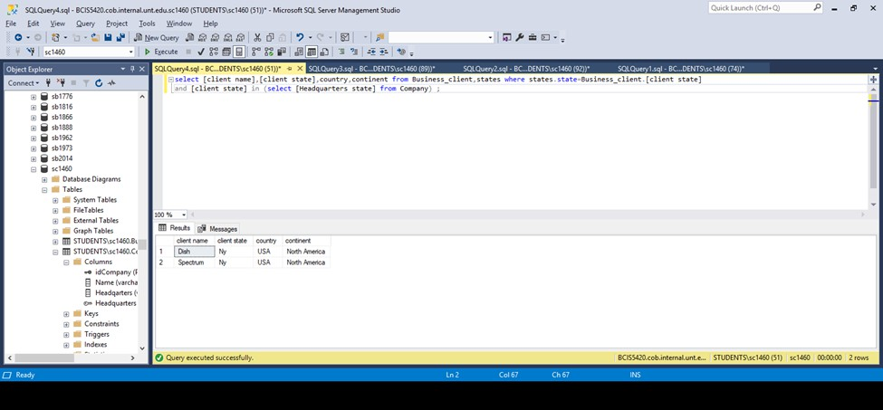
Comment:-- wearetryingtofindifthereisanyclientin the same region as there is a company headquater

- Displayingclientswhoordered morethan2 units
Querie:-select*fromBusiness_client,Order_info,Saleswhere Order_info.[idBussiness client]=Business_client.[idBussiness client]
AndSales.idOrder_info.idorderandquantity>2;
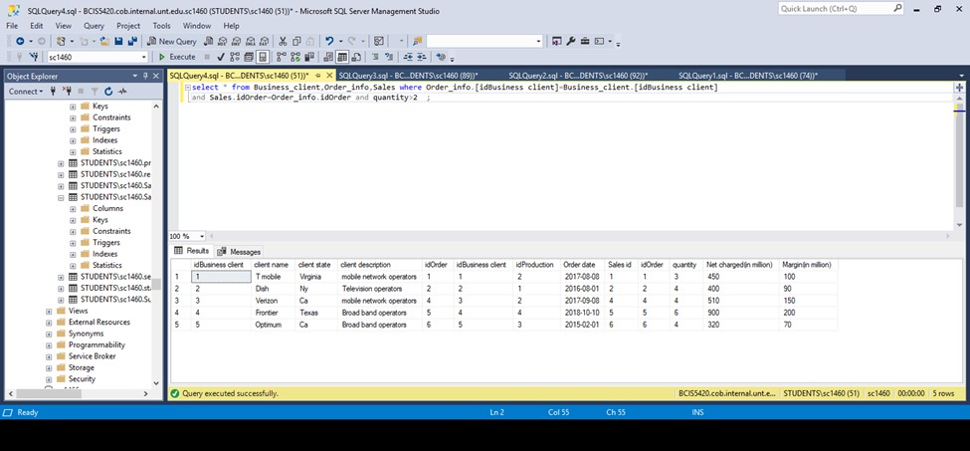
Comment: -- we are trying to find the clients who have orderedmorethan2satellitesalongwiththeirusesand description.

- Displayingclientswhospentmorethan1Billion
Querie: -select [client name],[total cost in thousands including request charges]fromtotal_charges_including_requestcharge,Business_client
Wheretotal_charges_including_requestcharge.[idBussinessclient]
=Business_client.[idBussinessclient]and[totalcostinthousands including request charges]> 1000000;
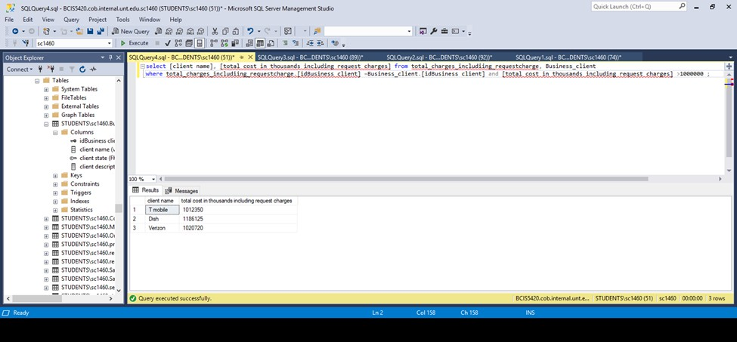
Comment:-WearetryingtoDisplaytheclientwho has spent more than 1 Billion in the past year

CONCLUSION:-
The Ideologythat we have tried to replicate isthat ifthe commercialsatelliteindustryhadadatabasewhatwould have been our areas of interest in the terms of questions and query’s
Wehavetriedtoinvolveandcombatissuesthathave arrived in terms of service and maintenance requests
Theunderstandingandinvolvementin-termsofregion and country with respect to headquarters, profits, sales and Requests.

